IBP PROJECT
Intelligent Business Performance Analytics and Decision Support Platform For Small Business

CSIS 4495 – Section 002
Instructor: | Padmapriya Arasanipalai Kandhadai
Student: | Hugh Tran | #SID: 300394597

Video link: https://youtu.be/3rzBsQ7UmWU

Introduction
  - Background
Today, many small businesses use data to understand their performance. For example, retail stores collect sales data, product information, and customer reviews. However, many small businesses only use simple reports or dashboards. These tools usually show past results but do not help predict the future.
Most dashboards answer questions like:
- How much did we sell?
- Which product sold the most?
- What was the revenue last month?
However, they do not answer:
- What will happen next month?
- Which product may have low sales soon?
- How should we adjust inventory?
This shows a gap between simple reporting and real decision support.

  - Problem statement
The main problem of this project is that many business systems only focus on past data. They do not combine:
- Performance analysis
- Forecasting
- Customer review analysis
- Business recommendations
In one single platform, this project tries to build a system that connects all these functions together.
  - Research purpose
The purpose of this project is to build a small business analytics platform that:
- Stores business data
- Analyzes sales performance
- Predicts future sales
- Analyzes customer reviews
- Provides simple business recommendations
The goal is to help small businesses make better decisions.
  - Research hypotheses

Hypothesis 1
If a small business platform combines performance analysis and forecasting in one system, then business users will better understand future sales trends.
This hypothesis can be tested by comparing historical performance analysis with forecasting results and checking whether forecasts provide additional insights.
Hypothesis 2
If month-over-month and time-based comparison are implemented, then sales trends and performance changes will become clearer.
This can be tested by analyzing whether the system can identify growth, decline, or seasonal patterns using time-based aggregation.
Hypothesis 3
If customer reviews are analyzed using sentiment classification, then the results can help explain changes in sales performance.
For example, if negative sentiment increases and sales decrease, this may show a relationship between customer satisfaction and business performance.
Hypothesis 4
If KPIs and recommendations are generated automatically, then decision-making becomes more structured and data-driven.
This can be tested by evaluating whether the system produces actionable suggestions based on KPI thresholds and forecasting results.
Summary of the initially proposed research project
In the original proposal, this project aimed to design and implement an Intelligent Business Performance Analytics and Decision Support Platform (IBP) for small businesses. The main goal was to create a complete system that integrates data storage, performance analysis, forecasting, customer review analysis, and business recommendations into one platform.
The project was designed as an applied research study. Instead of only discussing theory, the objective was to build a working system that demonstrates how analytics concepts learned in previous courses can be applied in real business situations.
  - Research Objectives
The initial proposal included the following objectives:
First, to design and implement an end-to-end analytics pipeline. This means the system would support the entire process from data upload to final report generation.
Second, to implement a structured database using SQL Server. The system would follow a layered architecture including raw data, clean data, and analytics data layers. This design ensures data traceability and accuracy.
Third, to calculate important business performance indicators (KPIs), such as:
- Total revenue
- Sales volume
- Average order value
- Product-level performance
- Monthly and daily sales trends
These KPIs would help business users understand how their company is performing over time.
Fourth, to perform time-based comparative analysis. The system would allow users to compare month-over-month and quarter-over-quarter performance in order to identify trends and seasonal patterns.
Fifth, to apply forecasting techniques to predict future sales and inventory demand. The forecasting results would be stored separately from actual data so that model performance could be evaluated later.
Sixth, to analyze text-based customer reviews using basic natural language processing techniques. The system would classify reviews into positive, neutral, or negative sentiment categories. These results would then be compared with sales trends to identify possible relationships.
Seventh, to generate business recommendations based on KPI results, forecasting outputs, and sentiment analysis. The goal was to convert data into actionable suggestions instead of only presenting numbers.
Finally, the project aimed to demonstrate practical skills in database management, backend development, analytics implementation, and system integration. The completed platform could also serve as a portfolio project for future employment opportunities.
  - Proposed System Architecture
The initial proposal included a three-layer data architecture:
Layer 1 – Raw Data
This layer stores uploaded files in their original format without modification. This ensures data traceability and allows reprocessing if needed.
Layer 2 – Clean Data
In this layer, data is validated, cleaned, and standardized. Fact and dimension tables are created for structured analysis.
Layer 3 – Analytics Data
This layer contains aggregated tables and calculated KPIs. It supports reporting, forecasting inputs, and dashboard visualization.
The system was planned to use an ELT (Extract–Load–Transform) approach. Data would first be loaded into SQL Server, and transformations would be performed inside the database.
  - Proposed Technology Stack
The original proposal planned to use the following technologies:
- Python for backend logic and analytics
- FastAPI as the backend framework
- SQL Server as the database management system
- Pandas for data processing
- Power BI for dashboard visualization
- HTML and CSS for a frontend interface
  - Expected Contributions
The initially proposed project aimed to contribute in three main ways:
Academic Contribution
The project connects theoretical knowledge from business intelligence, statistics, machine learning, and NLP courses to a practical system.
Practical Contribution
The system provides a structured and reusable analytics framework for small businesses.
Technical Contribution
The project demonstrates integration of backend development, database architecture, analytics logic, and reporting in one unified platform.
Changes to the proposal
- Feature Changes
Removal of Inventory Forecasting
In the original proposal, the system was designed to ingest both sales data and inventory data. The platform was expected to:
- Store inventory stock levels
- Analyze inventory turnover
- Forecast future inventory demand
- Suggest adjustments to inventory levels
However, during the implementation phase, it became difficult to find a suitable dataset that combines both sales data and inventory data in a consistent and reliable format. Most publicly available datasets only include sales transactions, but do not include detailed inventory stock records.
Because of this limitation, integrating both sales and inventory forecasting would require artificial data generation or unrealistic assumptions. This would reduce the reliability of the project. Therefore, a decision was made to narrow the project scope and focus only on sales data.
As a result of this change:
- The system now focuses on sales performance analysis only.
- Forecasting is limited to sales prediction.
- Inventory recommendation logic has been removed.
- The system architecture has been simplified.
However, the core research objective remains valid, which is to develop an integrated business analytics and decision-support platform.
The project still includes:
- ELT pipeline
- KPI analysis
- Time-based comparison
- Forecasting
- Text-based sentiment analysis
- Recommendation logic (based on sales trends)

- Technologies
Original Plan
In the original proposal, the front-end was planned to use only:
- HTML
- Basic CSS
The user interface was expected to be minimal. It would allow file upload and basic result display only. The focus at that time was mainly on backend logic and database design.
Actual Implementation and Added Technologies
During development, the front-end has been expanding and improving significantly. The system now looks more like a real business product instead of a simple prototype.
In addition to HTML and basic CSS, the following technologies were added:
- Bootstrap – for responsive layout and structured UI components
- JavaScript – for dynamic interaction and user input handling
- Jinja2 Templates – for integrating frontend pages with FastAPI backend
These technologies helped create:
- A structured navigation layout
- Styled buttons and forms
- Organized dashboard sections
- Dynamic content rendering
- Improved user interaction
The front-end shall include multiple pages such as:
- File upload page
- Analytics dashboard page
- KPI result display section
- Forecast result section
This makes the application more realistic and user-friendly.

- Timelines
Original plan
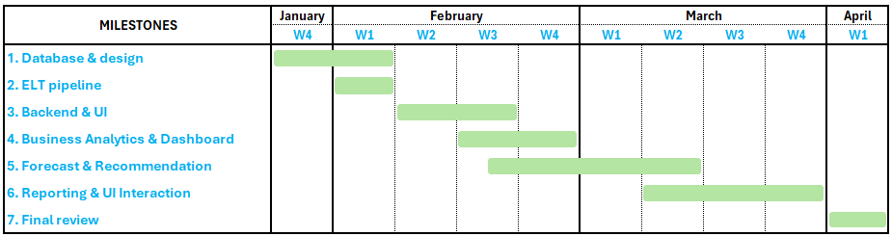
Adjusted plan
Compared to the initially proposed timeline, two milestones have been extended by one additional week:
- Milestone 4: Business Analytics & Dashboard
- Milestone 5: Forecast & Recommendation

Reason for Extending Business Analytics & Dashboard
This milestone required more time than originally planned due to additional technical works related to frontend development and dashboard integration.
The following tasks required extra time:
- Creating a Frontend for Displaying Dashboard
The initial plan focused mainly on backend analytics. However, during development, it became necessary to design and implement a proper frontend interface to display KPI results and dashboards.
This required:
- Designing dashboard layout
- Connecting backend APIs to frontend pages
- Testing data display consistency
- Improving user interaction
This development is more complex than originally estimated.
- Research on Integration Between SQL Server and Power BI
To generate professional dashboards, research is required on how Power BI connects to SQL Server.
This included:
- Understanding data connection methods
- Ensuring data refresh consistency
This research phase required additional time to ensure correct integration.
- Research on Embedding Power BI Dashboard into Frontend
Another technical challenge is researching how to display Power BI dashboards inside the web application.
This required studying:
- Power BI publishing options
- Web embedding methods
Since embedding dashboards into a custom frontend is not a basic feature, additional research and testing were necessary.
Because of these technical requirements, the milestone is extended by one week to ensure stable integration and proper implementation.
Reason for Extending Forecast & Recommendation
NLP has not been covered in detail in previous academic courses. Therefore, additional research is required to understand:
- Basic NLP concepts
- Text preprocessing methods
- Sentiment classification techniques
- Tokenization and feature extraction
Learning and implementing NLP required extra time because it is a new technical area.
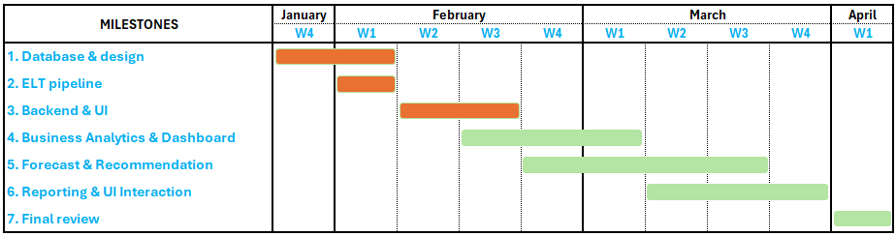
The adjusted plan

Project Planning and Timeline
Time | Milestone | Actions
Feb 23 – Mar 8, 2026 | Business Analytics & Dashboard | - Define and calculate key business KPIs such as revenue, sales volume, and average order value  - Perform product-level and time-based performance analysis  - Build dashboards to show trends and comparisons  - Enable time-range filtering for analytics  - Build interactive front-end
Mar 2 – Mar 22, 2026 | Forecast & Recommendation | - Train forecasting models using historical sales data  - Generate future sales forecasts  - Compare forecast results with historical performance  - Produce basic business recommendations based on analytics and forecasts
Mar 9 – Mar 29, 2026 | Reporting & UI Interaction | - Generate automated business review reports  - Combine KPIs, trends, forecasts, and recommendations into clear reports  - Allow users to select time ranges when generating reports  - Present analytical results clearly through the user interface
Mar 30 – Apr 5, 2026 | Final review | - Review and validate all system components  - Test the accuracy of analytics and report outputs  - Finalize documentation and the research report  - Prepare for project presentation

Implemented Features
- Database Architecture
The system uses three layers:
Layer 1: Raw Data, stores original uploaded data without changes.
Layer 2: Clean Data, data is cleaned and formatted.
Layer 3: Analytics Data, data is aggregated for KPI calculation and reporting.
This structure helps:
- Keep original data safe
- Improve data quality
- Support analytics
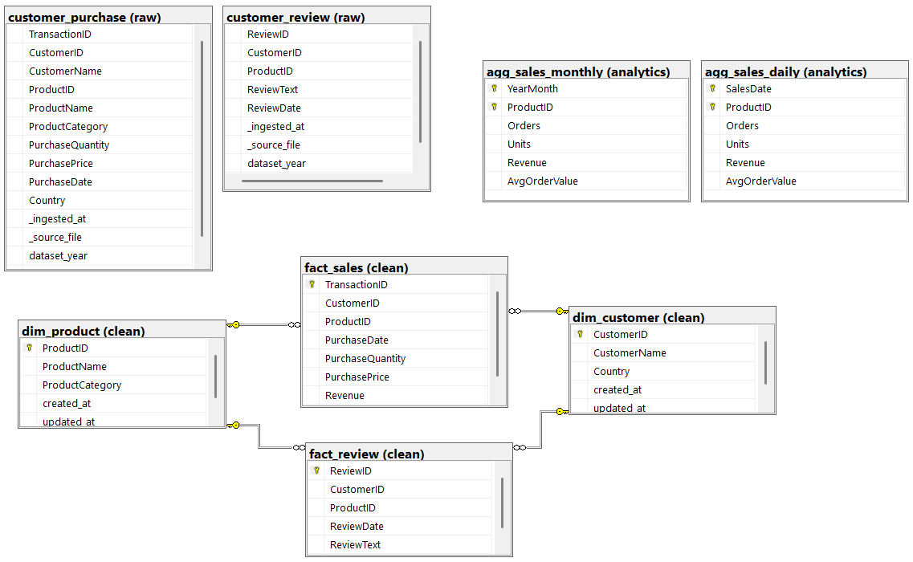
- ELT Pipeline
The system allows users to:
- Upload CSV files
- Store data in raw tables
- Load cleaned data into fact, dimension and analytics tables
This design supports data tracking and reprocessing.
Uploaded data successfully
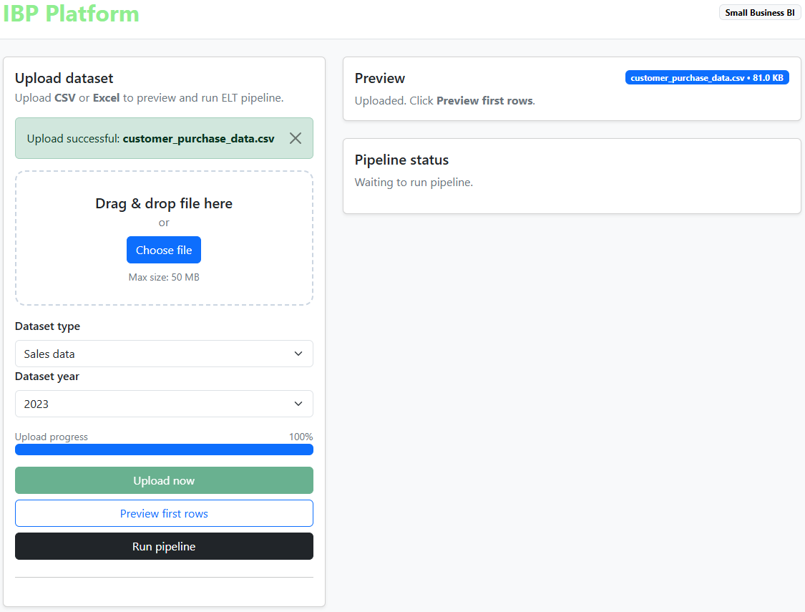

Preview first rows after uploading
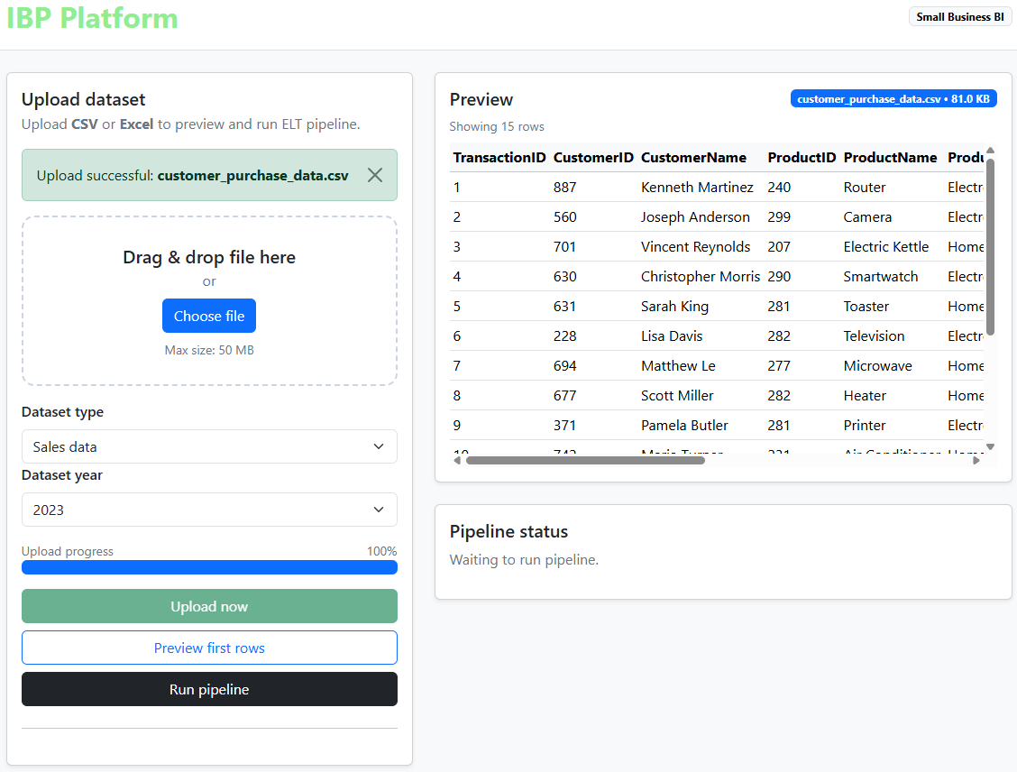
After clicking the “Run Pipeline” button, the “Pipeline Status” section is displayed for development and testing purposes only. It will be hidden in the production environment.
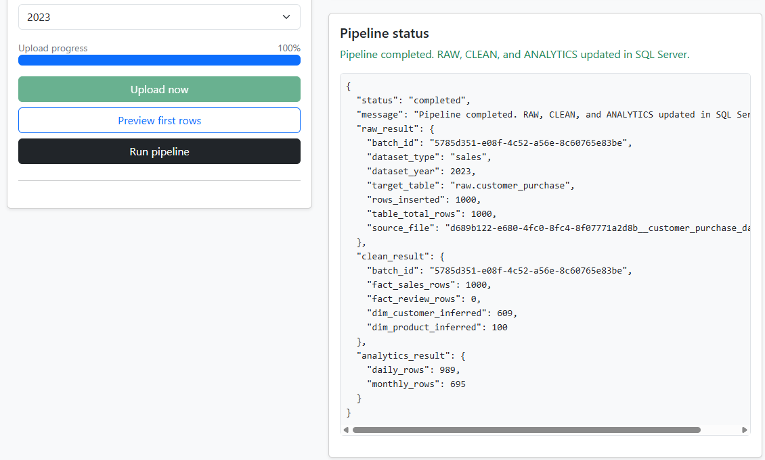
KPI Calculation
The system calculates:
- Average order value
- Daily/Monthly revenue
These KPIs help evaluate business performance.
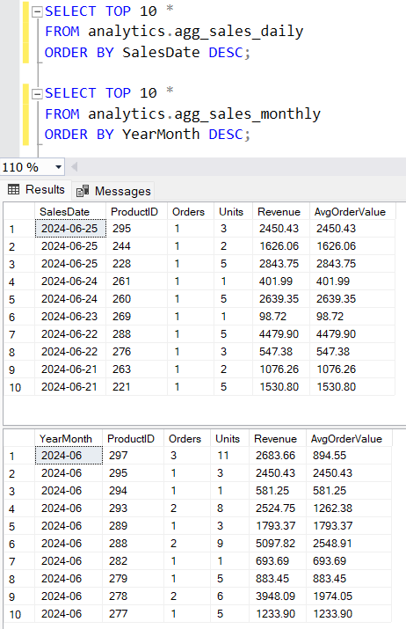

AI use section
AL Tool Name | Version, Account Type | Specific feature for which the AI tool was used | Value addition
ChatGPT | GPT-5.2 plus | Discuss system architecture design and layered database structure | I designed the actual database schema, created tables, and implemented SQL queries
 |  | Proposed technology options for the overall project (backend, database, visualization tools) | I evaluated the suggested options, conducted additional research, and made the final technology selection myself.
 |  | Provided code/debugging guidance for SQL, frontend, and backend codes | I identified logical errors in the code, corrected the implementation based on system testing results.
 |  | Help with academic writing, wording improvement, and report structure | I organized the content, selected relevant ideas, and adjusted the writing to match my project implementation.

Work log
Date | Number of Hours | Description
Jan 26, 2026 | 2 | - Searched for datasets that could be used for the project. Websites such as Kaggle and Google Dataset Search were checked. The focus was on finding data with sales information and customer reviews  - ChatGPT’s prompts:  - “what types of corpus of customer’s reviews could be?”  - “customer’s review corpus in csv is considered as structured or unstructured data?”
Jan 27, 2026 | 1.5 | - Continued searching for datasets on Kaggle, the UCI Machine Learning Repository, and Harvard Dataverse. Different datasets were reviewed to see if they met the project requirements  - ChatGPT’s prompts:  - “review this dataset to see whether is it meet requirements of my project?”  - “suggest sources of dataset as the project requirements”
Jan 29, 2026 | 3 | - Looked for more datasets on Data.gov and Kaggle  - Researched data scraping techniques from web  - ChatGPT’s prompts:  - “how to scrap data of sales and client’s review from a web”  - “any legal issues of the scraping?”
Jan 31, 2026 | 4 | - Selected a dataset from Kaggle due to time limits  - Set up environments (VSC, SQL Server Management System, ODBC)  - Created IBP database in SQL Server  - Created schemas for raw dataset  - Researched inserting the raw data into the database by Python  - ChatGPT’s prompts:  - “which dependencies must be installed for my project?”  - “how to connect backend and SQL server by python?”  - “any syntax issue of this table creation?”  - “how to inject data from csv into SQL server by python?”  - “explain in step by step these functions”
Feb 1, 2026 | 1 | - Loaded the raw sales and review data into the database using Python. Checked the results to make sure the data was loaded correctly.  - ChatGPT’s prompts:  - “any wrong syntax or unlogic of this function? and correct it”  - “explain in details these statements”
Feb 2, 2026 | 4 | - Studied data cleaning methods using Python.  - Created clean tables using dimension and fact tables in SQL Server.  - Transformed raw data into clean data  - ChatGPT’s prompts:  - “why should have dim and fact tables?”  - “dim & fact are for normalization purpose, is it right?”
Feb 3, 2026 | 3 | - Studied how to prepare data for Power BI.  - Created analysis tables and a summary view in SQL Server.  - ChatGPT’s prompts:  - “why don’t use data directly from the clean tables, instead of creating new analysis tables?”  - “why used view instead of creating another analysis table? ”
Feb 4, 2026 | 4 | - Drafted the project progress report  - ChatGPT’s prompts:  - “wording these paragraphs”
Feb 6, 2026 | 2 | - Updated the project progress report  - ChatGPT’s prompts:  - “how can use fastapi to connect a html frontend and backend in python”  - “explain these api in details, line by line”
Feb 8, 2026 | 1.5 | - Researched front-end's frameworks for uploading the dataset  - ChatGPT’s prompts:  - “which framework works best with html + fastApi?”  - “compare bootstrap and tailwind”  - “why should use jinja template? What if not using it?”
Feb 9, 2026 | 2 | - Started developing the FastAPI backend structure.  - ChatGPT’s prompts:  - “debug these code”  - “explain in details these statements”
Feb 10, 2026 | 3 | - Kept developing the FastAPI backend structure.  - Tested basic API endpoint to confirm backend server runs correctly.  - ChatGPT’s prompts:  - “debug these code”  - “explain in details these statements”
Feb 11, 2026 | 3 | - Developed file upload endpoint in FastAPI  - Tested uploading CSV files from local machine.  - ChatGPT’s prompts:  - “debug these code”  - “explain in details these statements”
Feb 13, 2026 | 2 | - Developed basic HTML form for dataset upload.  Integrated frontend form with FastAPI backend endpoint.  - ChatGPT’s prompts:  - “how to connect html form with fastapi backend?”  - “debug these code”  - “explain in details these statements”
Feb 16, 2026 | 2.5 | - Improved frontend layout using Bootstrap.  Organized upload section and status display messages.  - Tested full upload-to-database pipeline again.  - ChatGPT’s prompts:  - “how to display successful response in html”  - “debug these code”  - “explain in details these statements”
Feb 17, 2026 | 3 | - Tested layering process in SQL Server after frontend upload.  - Verified raw -> clean -> analytics transformation works correctly.  - Fixed issues in foreign key relationships.  - ChatGPT’s prompts:  - “why foreign key constraint failed?”  - “debug these code”  - “explain in details these statements”
Feb 18, 2026 | 2 | - Improved SQL aggregation queries in analytics layer.  - Tested daily and monthly summary tables.  - ChatGPT’s prompts:  - “debug these code”  - “explain in details these statements”
Feb 21, 2026 | 3 | - Draft the midterm report  - ChatGPT’s prompts:  - “wording these paragraphs”
Feb 22, 2026 | 3 | - Draft the midterm report  - Outlined structure of the demo video:  - ChatGPT’s prompts:  - “wording these paragraphs”
Feb 23, 2026 | 4 | - Made the video, finalized the midterm report

References
- tutorialspoint, Business Intelligence – Architecture
https://www.tutorialspoint.com/business-intelligence/business-intelligence-architecture.htm
- IBIMA Publishing, A five layered business intelligence architecture (2011)
chromeextension://efaidnbmnnnibpcajpcglclefindmkaj/https://ibimapublishing.com/articles/CIBIMA/2011/695619/695619.pdf
- Kanerika Inc, A complete guide to business intelligence architecture (Jan 29, 2025)
https://medium.com/@kanerika/a-complete-guide-to-business-intelligence-architecture-25ce2896a097
- GeeksforGeeks, FastAPI Introduction (Sept 23, 2025)
https://www.geeksforgeeks.org/python/fastapi-introduction/
- Astera Analytics Team, A guide for Python to SQL Server integration (Feb 14, 2025)
https://www.astera.com/knowledge-center/python-to-sql-server-integration/
- Dr. Fatih Hattatoglu, How to connect between Python and SQL? (Dec 22, 2024)
https://medium.com/academy-team/how-to-connect-between-python-and-sql-5f0639ccce73
- BI Tricks, How to connect SQL Server in Power BI (Sept 19, 2023)
https://www.youtube.com/watch?v=DGYbWBRxGGQ
- Nestor Adrianzen, How to connect SQL Server to Power BI [AdventureWorks2022 Sample Database] (Jun 7, 2025)
https://www.youtube.com/watch?v=DAhFcLHY0LY
- MAXQDA, What is a sentiment analysis?
https://www.maxqda.com/research-guides/sentiment-analysis?gad_source=1&gad_campaignid=868754387&gbraid=0AAAAAD-6Ox0Q7SJSayyvDBmq8U9RNL2p2&gclid=Cj0KCQiAm9fLBhCQARIsAJoNOctmGzW2DXZZKTy1e9Z4isnCXpp6OHrsJIvNr3hjJH7md6PTAn_bI6YaAoe6EALw_wcB
- GeeksforGeeks, What is text analytics? (Jul 23, 2025)
https://www.geeksforgeeks.org/data-science/what-is-text-analytics/
- Dataquest, Using machine learning and natural language processing tools for text analysis (Feb 28, 2022)
https://www.dataquest.io/blog/using-machine-learning-and-natural-language-processing-tools-for-text-analysis/
- PyData, Sean P.Rogers – Introduction to machine learning for text analysis and classification with Python (Sept 3, 2024)
https://www.youtube.com/watch?v=_ps6XQXA1lY
- Christian Ofori-Boateng, How to publish Power BI reports: a step-by-step process (Apr 3, 2024)
https://go.christiansteven.com/bi-blog/how-to-publish-power-bi-reports-a-step-by-step-process?utm_term=power%20bi%20integrate&utm_medium=ppc&utm_campaign=1.+PBRS-Search+(US+)&utm_source=adwords&hsa_cam=19872567087&hsa_acc=6168560490&hsa_src=g&hsa_ad=652240527744&hsa_tgt=aud-932430925173:kwd-2128074850707&hsa_ver=3&hsa_grp=147377883036&hsa_mt=p&hsa_net=adwords&hsa_kw=power%20bi%20integrate&gad_source=1&gad_campaignid=19872567087&gbraid=0AAAAAD4FRWSHUNPJUsSOmAPnnKKQvNzl3&gclid=Cj0KCQiAm9fLBhCQARIsAJoNOcviWEg5dO-r5LG0NKtGGwiSHf-uHZczQ9qDVqck_sd4LHoGN_YEv1MaAqmFEALw_wcB
- Microsoft Learn, Add a Power BI report or dashboard to a web page
https://learn.microsoft.com/en-us/power-pages/configure/add-powerbi-report
- GreeksForGreeks, How to add Bootstrap in a project? (July 23, 2025)
https://www.geeksforgeeks.org/bootstrap/how-to-add-bootstrap-in-a-project/
- GreeksForGreeks, How to create a progress bar using HTML and CSS? (July 15, 2025)
https://www.geeksforgeeks.org/web-templates/how-to-create-a-progress-bar-using-html-and-css/
- Fast API, Custom response – HTML, Stream, File, others
https://fastapi.tiangolo.com/advanced/custom-response/
- ChatGPT5.2 Plus

